**CICD EXPERIMENT – 3**

**Jenkins integration with GitHub and Maven**

1. Start the Jenkins service using “java –jar jenkins.war” in command prompt
2. Go to “localhost:8080” in a web browser
3. Click “New Item” option in Jenkins dashboard. Enter the item name and select maven project

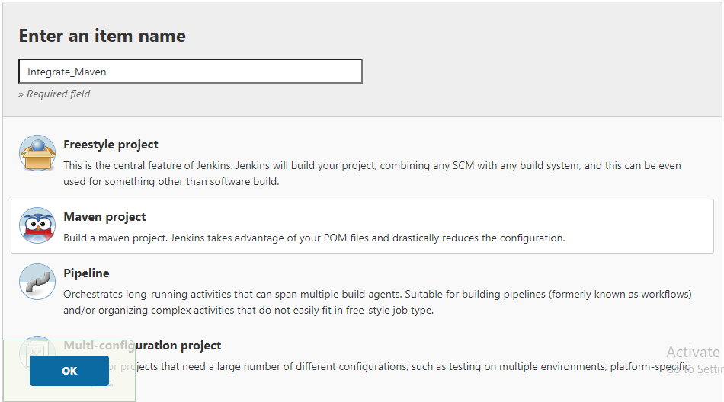

1. Now go to source code management tab and enter the URL of the github repository you want to integrate with 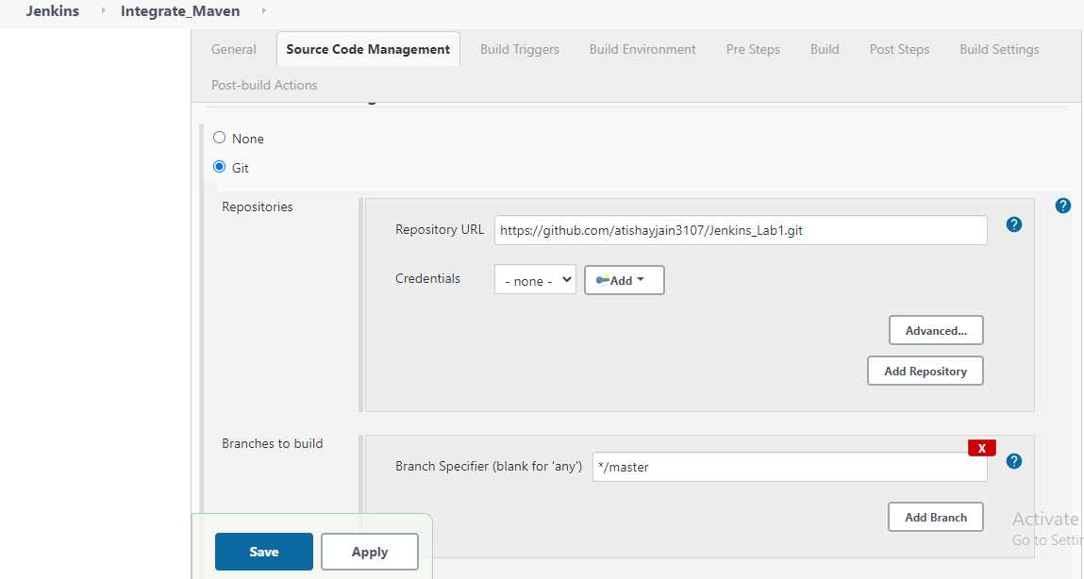
2. Now go to build tab and add the exact location of pom.xml file. If it’s inside a folder then, specify it as “{folder name}/pom.xml”
3. In goals and option section, specify “clean test install” as maven goals and hit the save button

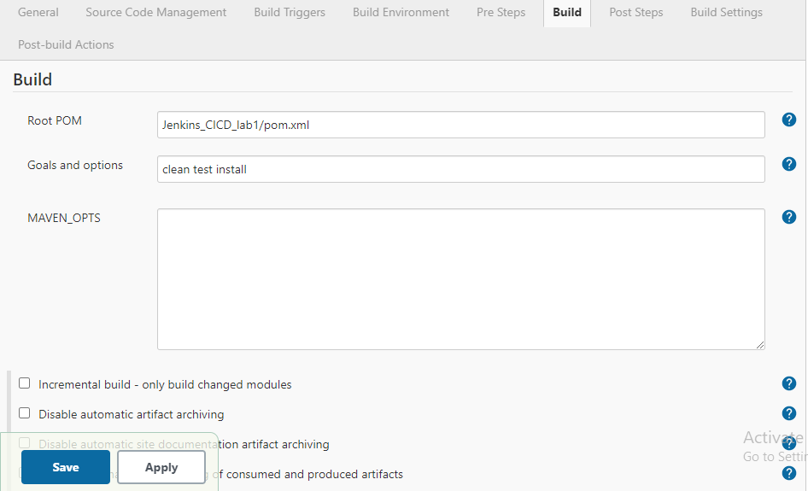

1. You will be redirected to the dashboard page. Here, select the workspace option

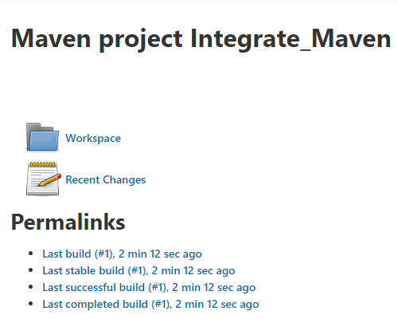

1. In that, you’ll find the folder named “target”. Open that folder and you’ll find a jar file which is created after maven goals run successfully

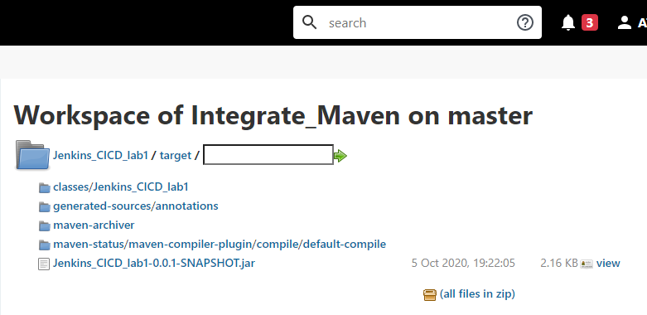

ATISHAY JAIN

500067694

R171218030

CSE, DEVOPS